ReactJS
ReactJS - Exercises
Gerry Byrne
David Wilson

Version 1.0


Amendment Record Sheet

Version No. | Date | Amendment Description | Amended By | Approved By
1.0 | 21 March 2017 | Approved document | Gerry Byrne | David Wilson

Contents
Exercise One – Basic Component returning HTML with an image 4
Exercise Two – Basic Component returning HTML with an image specified as a prop 7
Exercise Three – Component using the state object 11
Exercise Four – Composition of components 17

Exercise One – Basic Component returning HTML with an image
Components in React are the individual 'building blocks' of the application UI. Components are the heart and soul of React. They are custom React elements. They are usually extended with unique functionality and structure.

What to do
- Create a component called ImageComponentOne
- The component will display
  - a heading saying Smile Please!
  - another heading saying The photographer is about
  - an image called P1010694.jpg
  - at the position on the page with an id of contentgoeshere
- Run the application

How to do it:
- Open you text editor.
- Click on the File menu.
- Choose New.
- Click on the File menu.
- Choose Save As.
- Choose the location where you wish to save the file.
- In the text box to the right of the File name label enter the name of the HTML file you wish to create –. ReactComponentWithImage.html
- Choose Hyper Text Markup Language file from the drop down list to the right of the Save as type label.
- Click the Save button.
- Amend the code as shown below:

<!DOCTYPE html>
<html>
<head>
<meta charset="UTF-8" />
<title>Gerry Byrne - ReactJS Components Exercise</title>
<script src="https://cdnjs.cloudflare.com/ajax/libs/react/0.14.0/react.js"></script>
<script src="https://cdnjs.cloudflare.com/ajax/libs/react/0.14.0/react-dom.js"></script>
<script src="https://cdnjs.cloudflare.com/ajax/libs/react/0.13.3/JSXTransformer.js"></script>
<script src="https://cdnjs.cloudflare.com/ajax/libs/babel-core/5.8.24/browser.min.js"></script>
</head>
<body>
<div id="contentgoeshere"></div>
<script type="text/jsx">
class ImageComponentOne extends React.Component{
render() {
return (
<div>
<h1>Smile Please! </h1>
<h2>The photographer is about </h2>
<img src='P1010694.jpg' />
</div>
);
}
};
ReactDOM.render(<ImageComponentOne />, document.getElementById('contentgoeshere'));
</script>
</body>
</html>

- Click on the Run menu.
- Choose Launch in Chrome.

The browser window will appear with the following web page displayed:

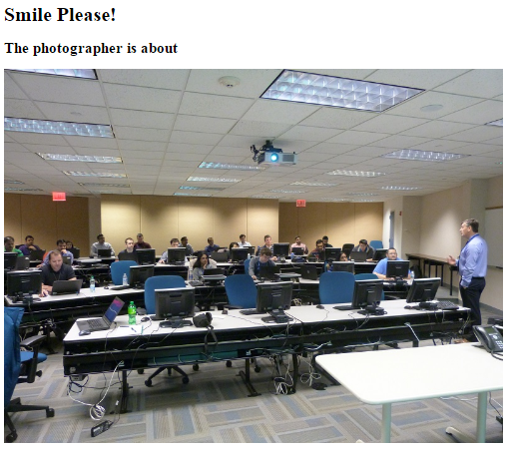
The ImageComponentOne class is defined as a subclass of the React Component class. It has a single render function which returns a h1, a h2 and image element. The ImageComponentOne component is constructed, < ImageComponentOne />, and rendered to the contentgoeshere div.

Exercise Two – Basic Component returning HTML with an image specified as a prop
Components in React are the individual 'building blocks' of the application UI.
Props can be thought of as a component’s options. Props are given as arguments to a component and look exactly like HTML attributes.

What to do
- Create a component called ImageComponentwithProps
- The component will display
  - a heading saying Smile Please!
  - another heading saying The photographer is about
  - an image called P1010694.jpg
  - at the position on the page with an id of contentgoeshere
  - the image will be passed as a prop to the image src {this.props.src}
  - the image will have a caption which will be passed as a prop {this.props.question}
(question='Question - Is Gerry talking too much - as usual???')
  - the image will have a caption which will be passed as a prop {this.props.answer}
(answer='Answer - No one listening as usual - so it makes no difference!!!')
  - both captions will be placed in separate spans
- Run the application

How to do it:
- Open you text editor.
- Click on the File menu.
- Choose New.
- Click on the File menu.
- Choose Save As.
- Choose the location where you wish to save the file.
- In the text box to the right of the File name label enter the name of the HTML file you wish to create –. ReactComponentWithImageAsProps.html
- Choose Hyper Text Markup Language file from the drop down list to the right of the Save as type label.
- Click the Save button.
- Amend the code as shown below:

<!DOCTYPE html>
<html>
<head>
<meta charset="UTF-8" />
<title>Gerry Byrne - ReactJS Tutorials</title>
<script src="https://cdnjs.cloudflare.com/ajax/libs/react/0.14.0/react.js"></script>
<script src="https://cdnjs.cloudflare.com/ajax/libs/react/0.14.0/react-dom.js"></script>
<script src="https://cdnjs.cloudflare.com/ajax/libs/react/0.13.3/JSXTransformer.js"></script>
<script src="https://cdnjs.cloudflare.com/ajax/libs/babel-core/5.8.24/browser.min.js"></script>
</head>
<body>
<div id="contentgoeshere"></div>
<script type="text/jsx">
class ImageComponentWithProps extends React.Component{
render() {
return (
<div>
<h1>Smile Please! </h1>
<h2>The photographer is about </h2>
<img src={this.props.src} />
<br/>
<span><b>{this.props.question}</b></span>
<br/>
<span><b>{this.props.answer}</b></span>
</div>
);
}
};
ReactDOM.render(<ImageComponentWithProps src='P1010694.jpg'
question='Question - Is Gerry talking too much - as usual???'
answer='Answer - No one listening as usual - so it makes no difference!!!'/>,
document.getElementById('contentgoeshere'));
</script>
</body>
</html>

- Click on the Run menu.
- Choose Launch in Chrome.

The browser window will appear with the following web page displayed:

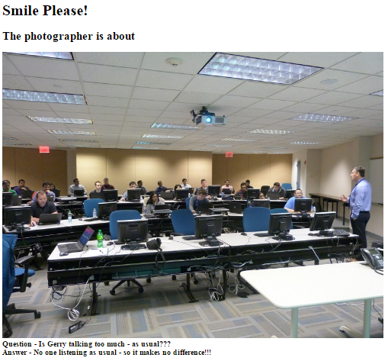

Inside the React render function, three props are passed to the ImageComponentWithProps;
- Image name
- question and
- answer
Inside the component’s render function the:
- image name prop is used as the src for the React image element
- question prop is used as plain text within a React span element
- answer prop is used as plain text within a React span element
We need to be clear that that a component should never change its props, props are immutable.
If we wish our component to have data that is mutable then we will use the state object.

Exercise Three – Component using the state object
The state object is internal to a component. It holds data which can change over time. We will create a button whose state changes when clicked.

What to do
- Create a component called ImageComponentWithImageAndState
- The component will display
  - a heading saying Smile Please!
  - another heading saying The photographer is about
  - an image called P1010694.jpg
  - at the position on the page with an id of contentgoeshere
  - the image will be passed as a prop to the image src {this.props.src}
  - the image will have a caption which will be passed as a prop {this.props.question}
(question='Question - Is Gerry talking too much - as usual???')
  - the image will have a caption which will be passed as a prop {this.props.answer}
(answer='Answer - No one listening as usual - so it makes no difference!!!')
  - both captions will be placed in separate spans
  - there will be a button with a liked icon (or similar)
  - when the button is clicked the state of a liked value (we will therefore need to setup state in the constructor, have a function which changes the state when called
  - on clicking the button an alert will notify the user of the new state
  - optional – add a counter to the button which is incremented when the liked value is true
- Run the application

How to do it:
- Open you text editor.
- Click on the File menu.
- Choose New.
- Click on the File menu.
- Choose Save As.
- Choose the location where you wish to save the file.
- In the text box to the right of the File name label enter the name of the HTML file you wish to create –. ReactComponentWithImageAndState.html
- Choose Hyper Text Markup Language file from the drop down list to the right of the Save as type label.
- Click the Save button.
- Amend the code as shown below:

<!DOCTYPE html>
<html>
<head>
<meta charset="UTF-8" />
<title>Gerry Byrne - ReactJS Tutorials</title>

<script src="https://cdnjs.cloudflare.com/ajax/libs/react/0.14.0/react.js"></script>
<script src="https://cdnjs.cloudflare.com/ajax/libs/react/0.14.0/react-dom.js"></script>
<script src="https://cdnjs.cloudflare.com/ajax/libs/react/0.13.3/JSXTransformer.js"></script>
<script src="https://cdnjs.cloudflare.com/ajax/libs/babel-core/5.8.24/browser.min.js"></script>
</head>

<body>
<div id="contentgoeshere"></div>

<script type="text/jsx">
class ImageComponentWithState extends React.Component{
constructor(props)
{
/*
Our component class has a constructor function which is
called when the component is initialised.
During our initialisation the component state is set.
In our example the case liked is set to false.

The super function must be called (with the props argument)
for React to prepare the class for rendering.
*/

super(props);

this.state = {liked: false};
this.state = {likecounter: 1}
this.toggleLiked = this.toggleLiked.bind(this)
}

/*
Our component has another new function called toggleLiked.
When activated the function calls setState on our component and this
is where the liked value is toggled (true to false or false to true).
*/
toggleLiked() {
this.setState({
liked: !this.state.liked
});
if(this.state.liked)
{
this.setState({likecounter:this.state.likecounter + 1});
alert(this.state.liked + this.state.likecounter );
}
}

render() {

/*
Within our component’s render function we have a variable called buttonClass
which is assigned either 'active' or nothing - depending on the liked state.
buttonClass is used as a class name on the React button element.
The button also has an onClick event handler which is set to the toggleLiked function.
The onClick handler uses an ES6 arrow syntax which is shorthand for
function(e) { return this.toggleLiked(e)}.
*/
const buttonClass = this.state.liked ? 'active' : '';

return (
<div>
<h1>Smile Please! </h1>
<h2>The photographer is about </h2>
<img src={this.props.src} />
<br/>
<div className='bar'>
<button onClick={(e) => {this.toggleLiked(e)}} className={buttonClass}>
<span><img src='liked.jpg' /></span>
</button>
</div>
<span><b>{this.props.question}</b></span>
<br/>
<span><b>{this.props.answer}</b></span>
</div>
);
}
};
ReactDOM.render(<ImageComponentWithState src='P1010694.jpg'
question='Question - Is Gerry talking too much - as usual???'
answer='Answer - No one listening as usual - so it makes no difference!!!'/>,
document.getElementById('contentgoeshere'));
</script>
</body>
</html>

- Click on the Run menu.
- Choose Launch in Chrome.

The browser window will appear with the following web page displayed. Clicking on the liked button will increment the counter if the value of liked is true.

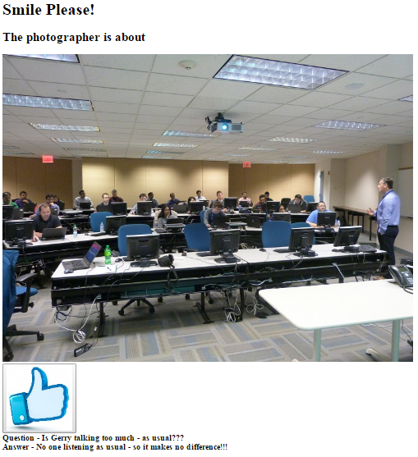

Notes:
- Having state in a component introduces a more complexity.
- Our component class has a constructor function which is called when the component is initialised. During this initialising the component state is set. In this case:
  - liked is set to false
  - likedcounter is set to 1
- The super function must be called (with the props argument) for React to prepare the class for rendering.
- The component has another new function toggleLiked. This function calls setState on the component which toggles the liked value and if the liked value is true the likedcounter value is incremented (its state changes).
- Within the component’s render function a variable buttonClass is assigned either ‘active’ or nothing - depending on the liked state.
- buttonClass is used as a class name on the React button element.
- The button also has an onClick event handler set to the toggleLiked function.
- The onClick handler uses an ES6 arrow syntax which is shorthand for function(e) { return this.toggleLiked(e)}.
When the component is rendered to the browser DOM:
- when the component’s button is clicked, toggleLiked is called
- The liked state is changed and the counter is incremented
- React re-renders the component to the virtual DOM
- The new virtual DOM is compared with the previous virtual DOM
- React isolates what has changed and updates the browser DOM

Exercise Four – Composition of components
When we use composition we mean combining smaller components to form a larger component. Inour case we will use the component we have created to be part of a larger component

What to do
- Create a component called ImageComponentWithImageAndState
- The component will display
  - a heading saying Smile Please!
  - another heading saying The photographer is about
  - an image called whatever is held in the JSON object called data. A part of the JSON object is shown below:
const data = [
{
url: 'P1010694.jpg',
question: 'Question - Is Gerry talking too much - as usual???',
answer: 'Answer - No one listening as usual - so it makes no difference!!!'
},
  - at the position on the page with an id of contentgoeshere
  - the image will be passed as a prop to the image src {this.props.src}
  - the image will have a caption which will be passed as a prop {this.props.question}
(question='Question - Is Gerry talking too much - as usual???')
  - the image will have a caption which will be passed as a prop {this.props.answer}
(answer='Answer - No one listening as usual - so it makes no difference!!!')
  - both captions will be placed in separate spans
  - there will be a button with a liked icon (or similar)
  - when the button is clicked the state of a liked value (we will therefore need to setup state in the constructor, have a function which changes the state when called
  - on clicking the button an alert will notify the user of the new state
  - optional – add a counter to the button which is incremented when the liked value is true
  - A new component called ImageAlbum will be created
  - It will the images, the question and the answer props
- Run the application

How to do it:
- Open you text editor.
- Click on the File menu.
- Choose New.
- Click on the File menu.
- Choose Save As.
- Choose the location where you wish to save the file.
- In the text box to the right of the File name label enter the name of the HTML file you wish to create –. ReactComponentWithImagesComposition.html
- Choose Hyper Text Markup Language file from the drop down list to the right of the Save as type label.
- Click the Save button.
- Amend the code as shown below:

<!DOCTYPE html>
<html>
<head>
<meta charset="UTF-8" />
<title>Gerry Byrne - ReactJS Tutorials</title>
<script src="https://cdnjs.cloudflare.com/ajax/libs/react/0.14.0/react.js"></script>
<script src="https://cdnjs.cloudflare.com/ajax/libs/react/0.14.0/react-dom.js"></script>
<script src="https://cdnjs.cloudflare.com/ajax/libs/react/0.13.3/JSXTransformer.js"></script>
<script src="https://cdnjs.cloudflare.com/ajax/libs/babel-core/5.8.24/browser.min.js"></script>
</head>
<body>
<div id="contentgoeshere"></div>
<script type="text/jsx">
class ImageComponentWithState extends React.Component{
constructor(props)
{
/*Our component class has a constructor function which is
called when the component is initialised.
During our initialisation the component state is set.
In our example the case liked is set to false.

The super function must be called (with the props argument)
for React to prepare the class for rendering. */
super(props);
this.state = {liked: false};
this.state = {likecounter: 1}
this.toggleLiked = this.toggleLiked.bind(this)
}
/* Our component has another new function called toggleLiked.
When activated the function calls setState on our component and this
is where the liked value is toggled (true to false or false to true). */
toggleLiked() {
this.setState({
liked: !this.state.liked
});
if(this.state.liked)
{
this.setState({likecounter:this.state.likecounter + 1});
alert(this.state.liked + this.state.likecounter );
}
}
render() {
/*Within our component’s render function we have a variable called buttonClass
which is assigned either 'active' or nothing - depending on the liked state.
buttonClass is used as a class name on the React button element.
The button also has an onClick event handler which is set to the toggleLiked function.
The onClick handler uses an ES6 arrow syntax which is shorthand for
function(e) { return this.toggleLiked(e)}. */
const buttonClass = this.state.liked ? 'active' : '';

return (
<div className='image'>
<h1>Smile Please! </h1>
<h2>The photographer is about </h2>
<img src={this.props.src} />
<br/>
<div className='bar'>
<button onClick={(e) => {this.toggleLiked(e)}} className={buttonClass}>
<span><img src='liked.jpg' /></span>
</button>
</div>
<span><b>{this.props.question}</b></span>
<br/>
<span><b>{this.props.answer}</b></span>
</div>
)
}
}
class ImageAlbum extends React.Component
{
render() {
const images = this.props.images.map((image) => {
return <ImageComponentWithState src={image.imagename} question={image.question} answer={image.answer}/>
});
return (
<div className='image-gallery'>
{images}
</div>
);
}
};
const data = [
{
imagename: 'P1010694.jpg',
question: 'Question - Is Gerry talking too much - as usual???',
answer: 'Answer - No one listening as usual - so it makes no difference!!!'
},
{
imagename: 'P1010682.jpg',
question: 'Question - Is Gerry talking too much - as usual???',
answer: 'Answer - No one listening as usual - so it makes no difference!!!'
},
{
imagename: 'P1010680.jpg',
question: 'Question - Is Gerry talking too much - as usual???',
answer: 'Answer - No one listening as usual - so it makes no difference!!!'
}
];
ReactDOM.render(<ImageAlbum images={data} />,
document.getElementById('contentgoeshere'));
</script>
</body>
</html>

- Click on the Run menu.
- Choose Launch in Chrome.

The browser window will appear with the following web page displayed. Clicking on any of the liked buttons will increment its unique counter if the value of liked is true.

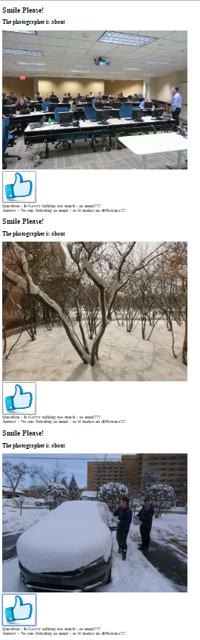

http://www.jackcallister.com/2015/08/30/the-react-quick-start-guide-es6-edition.html

